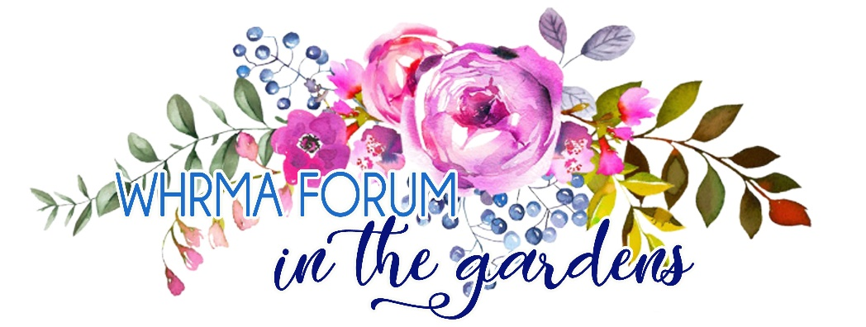
Wiregrass Human Resource Management Association’s
20th Annual Forum: October 9th, 2019
PENDING 7 HRCI/SHRM Credits
Location: Dothan Botanical Gardens 5130 Headland Ave. Dothan, AL 36303
Sponsor Registration Form & Invoice
Name: ____________________________________
Company Name: ____________________________
Address:___________________________________
Phone Number: _____________________________
Email Address: ______________________________
Sponsorship Levels (please indicate your chosen level):
- ____Gold- $750 Includes:
Prominent recognition in key locations & on forum materials and 1 forum participant registration.
- ____Silver- $500 Includes:
Recognition in key locations & on forum materials and 1 forum participant registration.
- ____Bronze- $250 Includes:
Recognition on all forum materials.
Payment Method:
- Check Made Payable to WHRMA
- Credit Card: ____Amex_____Discover_____Mastercard____Visa
Name on Credit Card: _____________________________
Card Number: ___________________________________
(credit card payments may also be called in to Tracy Whiddon at 334-793-6855, ext. 250)
Thank YOU for being a 2019 Sponsor!
Registration forms can be returned by mail: PO Box 10397 Dothan, AL 36304 or email traceyw@lbaproperties.com

